Coding and Solution

|  |  |
| --- | --- |
| Team ID | PNT2022TMID45278 |
| Project Name | Real-time river water quality monitoring and control system |

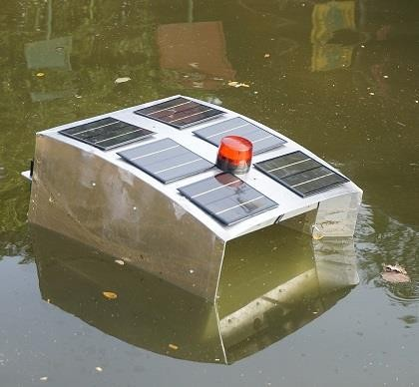Exception Handling

We have planned to transfer the message to the cleaning robot to implement cleaning

* **Every time the message is transferred to the cloud**
* **And also transferred to the Robot**
* **Messages are collected by Node-RED and showing in dashboard**